1. In order to do an OHS course designed for employees hired under civil-law contracts, it is necessary to first activate the employee e-mail account and acquire Active Directory (AD) login and password. For more information, contact the unit with which you have signed the civil-law contract.

2. In order to do an e-learning OHS course (self-study) designed for employees hired under civil-law contracts, please follow the instructions below:

2.1. **In your web browser** (we recommend using Firefox or Chrome) go to the course website: <https://eportal.pwr.edu.pl/course/view.php?id=4674&lang=en>.

2.2. Select the **“Użytkownicy USOS/AD (USOS/AD Users) OAuth2”** log-in option.

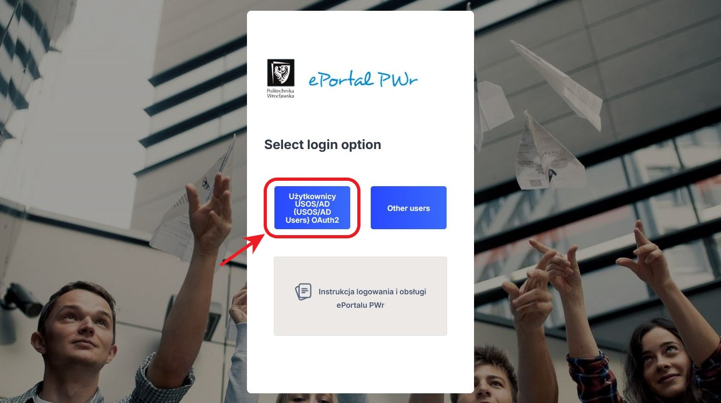

2.3. Log in to ePortal using your **AD login and password**.

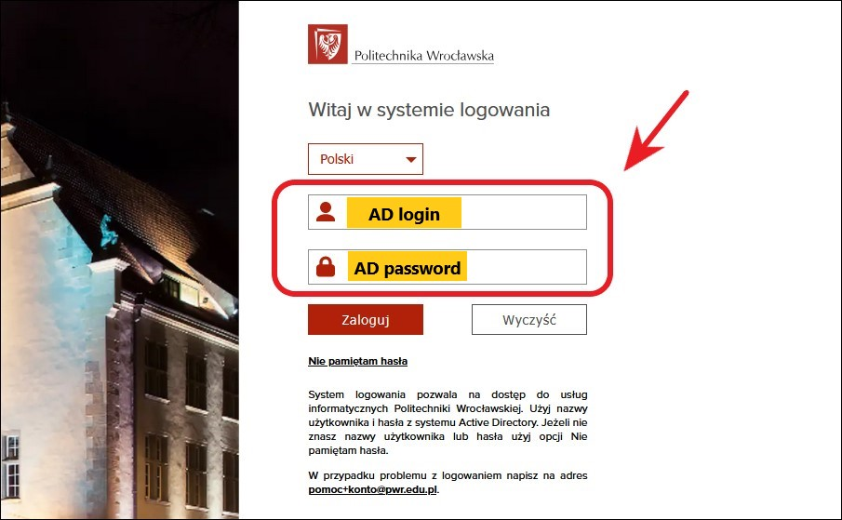

2.4. After you have logged in successfully, the system will require you to enter **the access key to the OHS e-course** which is: **BHP-2425-UCP**.

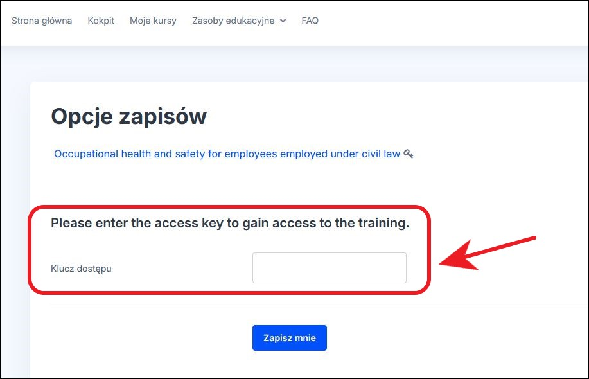

2.5. Start the OHS course for employees hired under civil-law contracts.

2.6. **A course completion certificate should be generated for you** after you have read all the course materials.

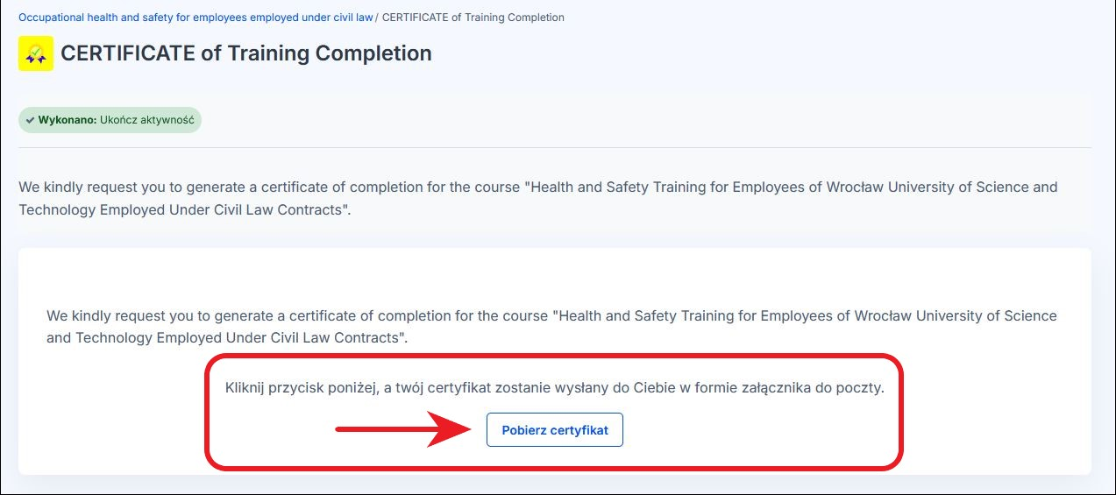

3. The course completion certificate will be sent to your employee e-mail address.

*The certificate should be made available to the person responsible for concluding and settling civil-law contracts for the provision of teaching services in the unit in which the contract is concluded, for inclusion in the documentation.*

Technical support e-mail addresses:

* for issues with e-mail accounts: [pomoc+poczta@pwr.edu.pl](mailto:pomoc+poczta@pwr.edu.pl)

* for issues with AD login / password: [pomoc+ad@pwr.edu.pl](mailto:pomoc+ad@pwr.edu.pl)

* for issues with access to the course in ePortal: [eportal@pwr.edu.pl](mailto:eportal@pwr.edu.pl)